Large Bedroom - CIRS   
Before Sorting Sal…

7

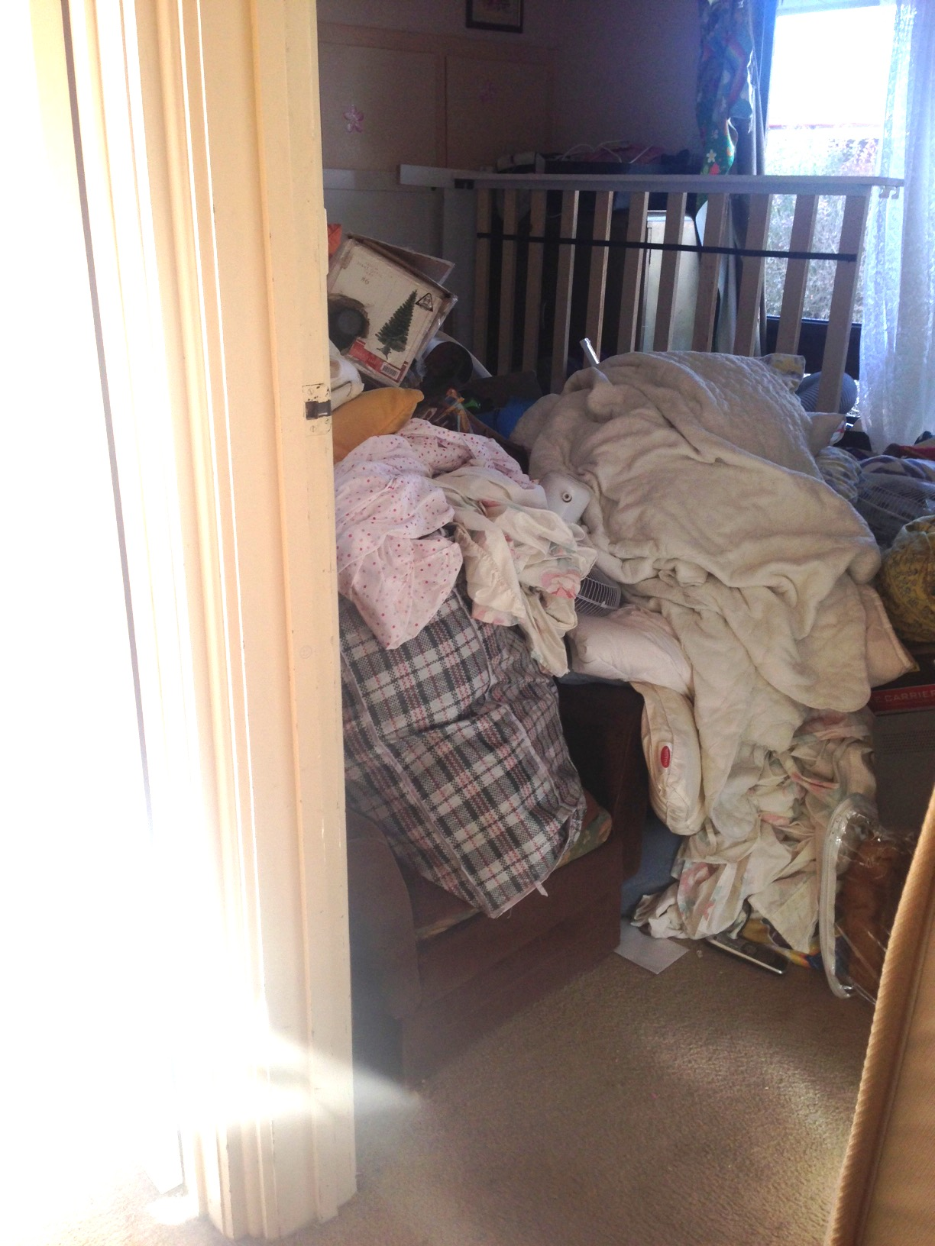  
  
After some help from Sorting Sal…

  
 CIRS Rating 7 – 8  
 The Goal:   
 “I want to be able to have my kids come   
 and stay in this room.”

