Small Storage Area - CIRS   
BEFORE ***Sorting Sal***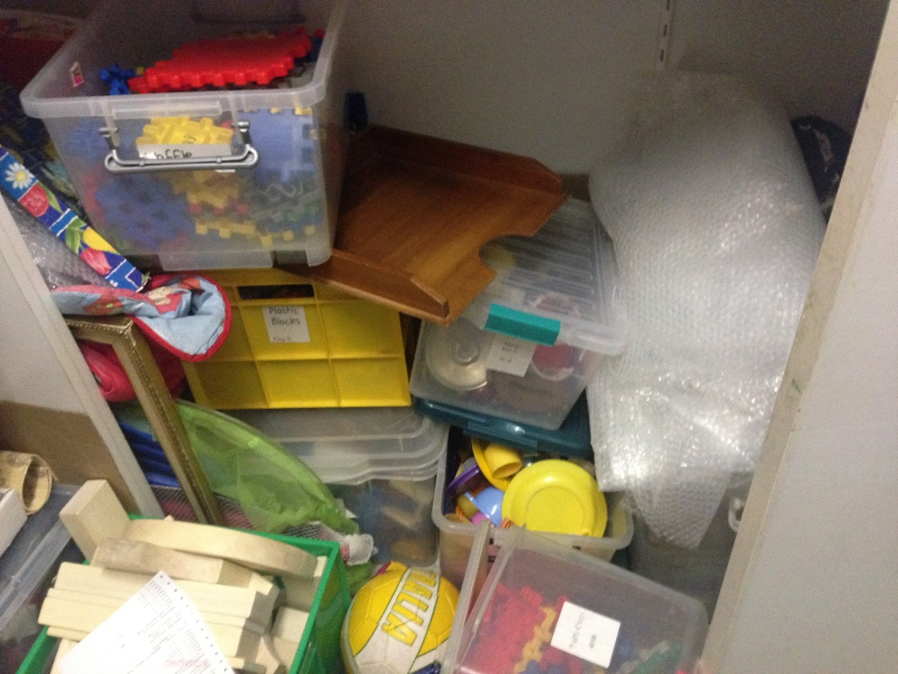AFTER ***Sorting Sal***  
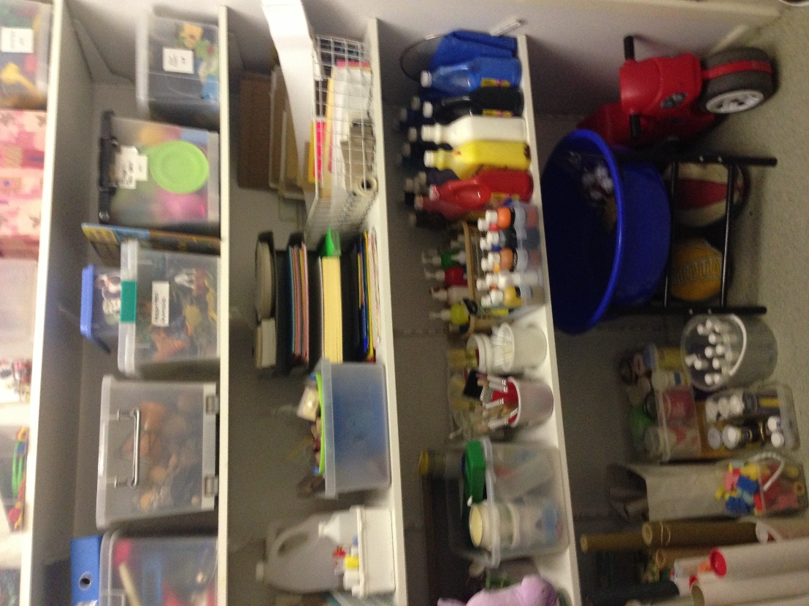

4

